Population Ecology Notes:

Name 3 properties used to study the environment:  Define “population growth” in your own words:  Why is exponential growth in a population unrealistic? | - Population Ecology  - Population ecology studies ___________________ from the point of view of the _____________ and _________________ of their populations  - Study the environment by measuring certain properties  - Size  - Density  - Definition of population:  - 4 things that can affect the size of populations  - Birth rate  - Rate at which new members are _________________  - Death rate  - Rate at which members are _____________________  - Immigration  - Rate at which new members are _____________________________________________  - Emigration  - Rate at which members are _____________________________________________  Population Growth  - Population growth occurs when the combination of ___________________ and ____________________ exceeds (faster than) _____________________ and ___________________  - Two types of population graphs  - _________________ (J-curve)  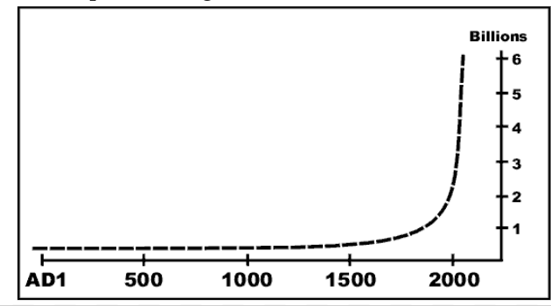  - In general, organisms will reproduce as much as they possibly can!  - However, a population does not grow ________________. At some point, the population stops growing and _______________ as a result of one or more limiting factors.  - A ____________ is a resource or environmental condition that limits a population’s growth, i.e. reduces the size or distribution of a population  - Over time, there is a dynamic balance between ____________ (i.e. reproduction) and ____________ that causes population sizes to ____________.  - Carrying Capacity  - Limiting factors for populations are usually ___________ (e.g. food, water, habitat), and there is a ___________ amount of these resources in any environment.  - __________ = the number of organisms the environment can support over time  - A population can temporarily _________________________ its carrying capacity.  - If there are not enough resources, organisms might _______________________________.  Move, change, or die!  - Populations can ____________________ in response to predators, seasons, etc.  - Population sizes often ______________ .  - ____________________ (s-curve)  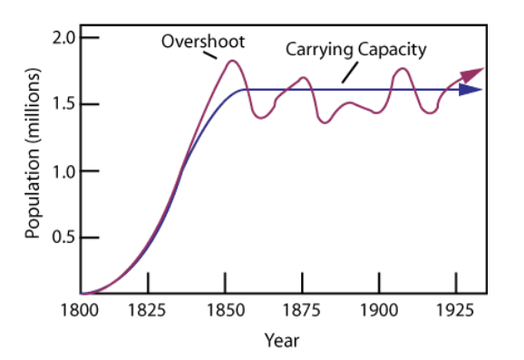  Changes in Carrying Capacity  - Extreme changes in ___________________ or _________________ can destabilize the system ________________________________________  ___________________________________________________________  - Examples:  Earth Overshoot Day

